JS PRACTICE 01

1. Let's create a menu that fixed 2 generation like the images at “imgs/shallow-menu”

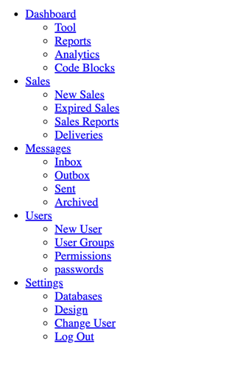

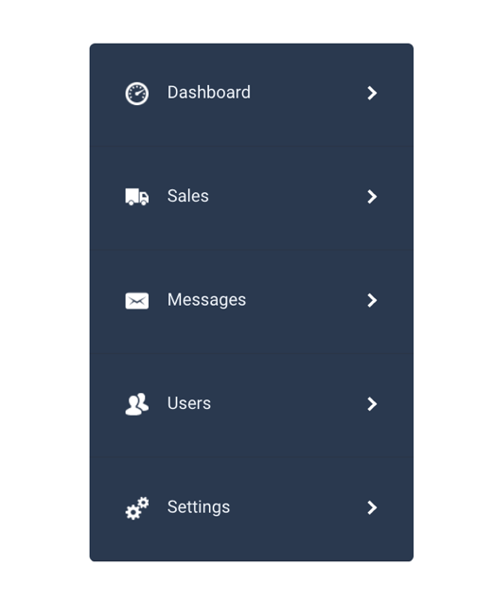

With the data at: “menu/shallow.js”

Note that: don’t use any HTML, you need to use js to render anything

- If a menu is active, another menu will be collaped

1. Let's create a dynamic menu like this image in this folder “imgs/deep-menu”

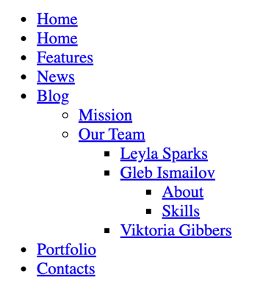

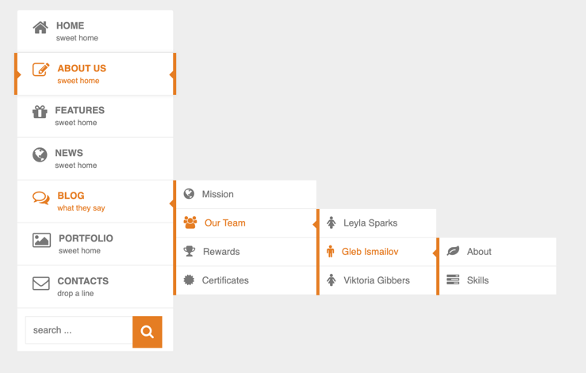

With the data at: “menu/deep.js”

Note that: don’t use any HTML, you need to use js to render anything

3.

- Lets create a array that a timeline list

- After that, lets create a timeline using the array that you was created in previous step

- This is expected result

